ASSIGNMENT 01

Q1. Implement following function to delete element from specified position in given array. The function should return the updated logical size of array.
int deleteFromPosition(int[] arr, int n, int pos);

Code:
package in.cdac;
import java.util.Scanner;
public class Program01 {
public static int deleteFromPosition(int[] arr, int n, int pos) {
if(pos < 0 || pos > n) {
System.out.println("Invalid Position!!!");
}
for(int i=pos; i<n-1; i++)
{
arr[i] = arr[i+1];
}
return --n;
}
public static void main(String[] args) {
try(Scanner scanner = new Scanner(System.in))
{
//int []arr = {10,20,30,45,55};
int []arr;
System.out.println("Enter size for array: ");
int n = scanner.nextInt();
arr = new int[n];
System.out.println("Enter "+ n +" Elements in the array: " );

for(int i=0; i<n; i++) {
arr[i] = scanner.nextInt();
}
System.out.println("Enter the position to be deleted: ");
int pos = scanner.nextInt();
System.out.println("Before Operation: ");
for(int i = 0; i < n; i++)
{
System.out.println(arr[i]);
}
n = deleteFromPosition(arr, arr.length, pos);
System.out.println("After Operation: ");
for(int i = 0; i < n; i++)
{
System.out.println(arr[i]);
}
}
}
}

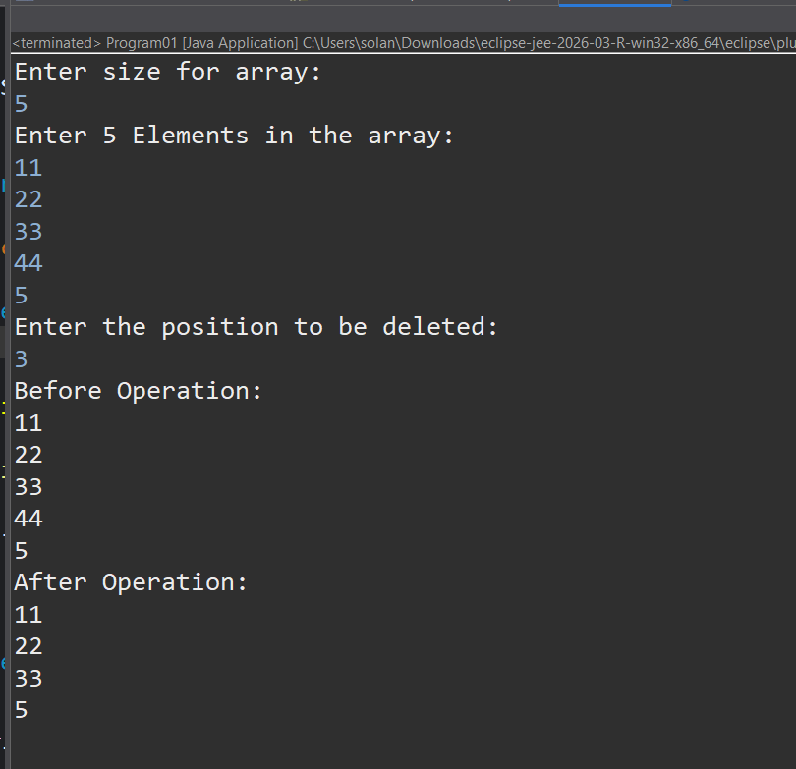

Q2. Implement a Stack class using resizable array that implements the Stack interface defined in class.
Throw appropriate exception when required.

Code:

Stack.java { Interface }

package in.cdac;

public interface Stack<T> {

public T peek();
public void push(T data) throws Exception;
public T pop();
public boolean isEmpty();
public void displayStack();
}

StackADT.java { Class that implements Stack Interface }
package in.cdac;
public class StackADT<T> implements Stack<T> {
private T[] arr;
private int top;
private int size;
// Parameterized Constructor
@SuppressWarnings("unchecked")
public StackADT(int s) {
this.size = s;
this.arr = (T[]) new Object[this.size];
this.top = -1;
}

@Override
public boolean isEmpty() {
if(top == -1) {
return true;
}
else {
return false;
}
}
@Override
public T peek() {
if(isEmpty()) return null;
return arr[top];
}
@Override
public void push(T data) throws Exception{
if(top == size - 1) {
throw new Exception("Stack is Full.");
}
arr[++top] = data;
}
@Override
public T pop() {
if(isEmpty()) {
System.out.println("Stack is Empty.");
return null;
}
T popedElemenT = arr[top];
arr[top] = null;
top--;
return popedElemenT;
}
@Override
public void displayStack() {
if(isEmpty()) {
System.out.println("Stack is empty");
}
System.out.println("Stack elements Top to Down manner.");
for(int i=top; i>=0; i--) {
System.out.print(arr[i] + " ");
}
}
}

StackMain.java { Main Program }
package in.cdac;

import java.util.Scanner;

public class StackMain {

public static void main(String []args) throws Exception{

Scanner scanner = new Scanner(System.in);
int choice;
System.out.println("Enter size fo stack: ");
int s = scanner.nextInt(); // s = 5

StackADT<Integer> stackObj = new StackADT<>(s);

do {
System.out.println("1. Push\n"
+ "2. Pop\n"
+ "3. Peek\n"
+ "4. isEmpty\n"
+ "5. Display Stack\n"
+ "6. Exit");
choice = scanner.nextInt();
switch(choice) {
case 1: {
System.out.println("Enter a number to enqueue: ");
stackObj.push(scanner.nextInt());
}
break;
case 2: {
System.out.println(stackObj.pop());
}
break;
case 3: {
System.out.println(stackObj.peek());
}
break;
case 4: {
stackObj.isEmpty();
}
break;
case 5: {
stackObj.displayStack();
}
break;
case 6: {
System.out.println("Exiting.......");
}
break;
}
}while(choice != 6);
scanner.close();
}
}
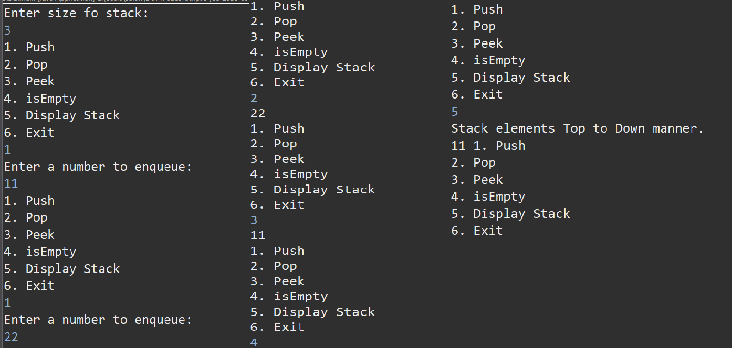

Q3. Define Queue as ADT (Refer to class notes).

Code:

Queue.java { Interface }

package in.cdac;

public interface Queue<T> {

public void enqueue(T data) throws Exception;
public T dequeue() throws Exception;
public boolean isEmpty();
public boolean isFull();
}

QueueADT.java { Class that implements Queue interface }
package in.cdac;

public class QueueADT<T> implements Queue<T> {
private T[] arr;
private int rear;
private int front;
private int size;
// Parameterized Constructor
@SuppressWarnings("unchecked")
public QueueADT(int s) {
this.size = s;
this.arr = (T[]) new Object[size];
this.front = 0;
this.rear = -1;
}
@Override
public boolean isEmpty() {
return front > rear;
}

@Override
public boolean isFull() {
return rear == size - 1;
}
@Override
public void enqueue(T data) throws Exception {
if(isFull()) {
throw new Exception("Queue is Full");
}
arr[++rear] = data;
}

@Override
public T dequeue() throws Exception {
if(isEmpty()) {
throw new Exception("Queue is Empty");
}
T dequeuedElement = arr[front];
arr[front] = null;
front++;
return dequeuedElement;
}

public void displayQueue() {
if(isEmpty()) {
System.out.println("Queue is empty.");
}
System.out.println("Queue: ");
for(int i = front; i <= rear; i++) {
System.out.print(arr[i] + " ");
}
System.out.println();
}
}

QueueMain.java { Main Program }
package in.cdac;
import java.util.Scanner;
public class QueueMain {
public static void main(String[] args) throws Exception {
Scanner scanner = new Scanner(System.in);
int choice;
System.out.println("Enter size for the Queue: ");
int s = scanner.nextInt();
QueueADT<Integer> queueObj = new QueueADT<>(s);
do {
System.out.println("1. Enqueue\n"
+ "2. Dequeue\n"
+ "3. isEmpty\n"
+ "4. Display Queue\n"
+ "5. Exit");
choice = scanner.nextInt();
switch(choice) {
case 1: {
System.out.println("Enter a number to enqueue: ");
queueObj.enqueue(scanner.nextInt());
}
break;
case 2: {
System.out.println(queueObj.dequeue());
}
break;
case 3: {
queueObj.isEmpty();
}
break;
case 4: {
queueObj.displayQueue();
}
break;
case 5: {
System.out.println("Exiting.......");
}
break;
}
}while(choice != 5);
scanner.close();
}
}

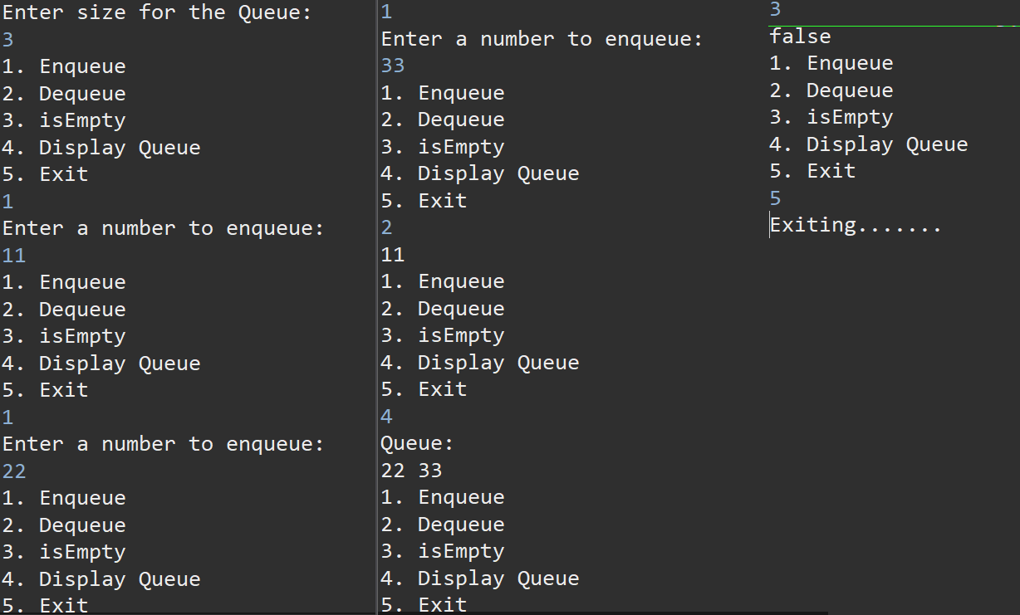

Q4. Implement a Generic Queue class using array that implements the Queue interface defined in Q1.
Throw appropriate exception when required.
Code:

Queue.java { Interface }

package in.cdac;
public interface Queue<T> {

public void enqueue(T data) throws Exception;
public T dequeue() throws Exception;
public boolean isEmpty();
public boolean isFull();
}

CircularQueueADT.java { Class that implements Queue interface }

package in.cdac;
public class CircularQueue<T> implements Queue<T> {
private T[] arr;
private int rear;
private int front;
private int size;
private int currCapacity;
// Parameterized Constructor
@SuppressWarnings("unchecked")
public CircularQueue(int s) {
this.size = s;
this.arr = (T[]) new Object[size];
this.front = 0;
this.rear = -1;
this.currCapacity = 0;
}

@Override
public boolean isEmpty() {

return currCapacity == 0;
}

@Override
public boolean isFull() {

return currCapacity == size;
}

@Override
public void enqueue(T data) throws Exception {
if(isFull()) {
throw new Exception("Queue is Full");
}
rear = (rear + 1) % size;
arr[rear] = data;
currCapacity++;
}

@Override
public T dequeue() throws Exception {
if(isEmpty()) {
throw new Exception("Queue is Empty");
}

T dequeuedElement = arr[front];
arr[front] = null;
front = (front + 1) % size;
currCapacity--;
return dequeuedElement;
}

public void displayQueue() {
if(isEmpty()) {
System.out.println("Queue is empty.");
}

System.out.println("Queue: ");
for(int i = front; i <= rear; i++) {
System.out.print(arr[i] + " ");
}
System.out.println();
}

}

CircularQueueMain.java { Main Program }

package in.cdac;
import java.util.Scanner;
public class CircularQueueMain {
public static void main(String[] args) throws Exception{
Scanner scanner = new Scanner(System.in);
int choice;
System.out.println("Enter size for the Queue: ");
int s = scanner.nextInt();

QueueADT<Integer> queueObj = new QueueADT<>(s);

do {
System.out.println("1. Enqueue\n"
+ "2. Dequeue\n"
+ "3. isEmpty\n"
+ "4. Display Queue\n"
+ "5. Exit");
choice = scanner.nextInt();
switch(choice) {
case 1: {
System.out.println("Enter a number to enqueue: ");
queueObj.enqueue(scanner.nextInt());
}
break;
case 2: {
System.out.println(queueObj.dequeue());
}
break;
case 3: {
System.out.println(queueObj.isEmpty());
}
break;
case 4: {
queueObj.displayQueue();
}
break;
case 5: {
System.out.println("Exiting.......");
}
break;
}
}while(choice != 5);
scanner.close();
}

}



